**ExoScan Automation Application**

**Overview**

ExoScan is Windows desktop software that automates the imaging and the photometric capture of exoplanet transits through application of the TheSky™ Professional astroimaging platform.

Exoplanet transits can be revealed by a dip of apparent magnitude in a host star. The dip is normally not more than around 20 or 30 milli-magnitudes. The duration of the transit is on the scale of at most a few hours. The rise and fall times are in terms of a few minutes. The magnitude of known exoplanet host stars seems to be in the low teens and biased towards reddish spectra. A given size exoplanet will probably produce a greater percentage decrease in the relative magnitude in a smaller star (dimmer, redder and closer) than a larger star (brighter, bluer and farther).

Collection of a series of images over several hours from which reliable milli-magnitude stellar brightness data can be plotted faces a number of obstacles: seeing variation, air mass extinction, temperature variability, and optics imperfections among others. One can largely compensate for these sources of image-to-image variability by image noise reduction and field differential photometry. That is, using the cataloged spectra of background light sources (stars) for calibrating the apparent brightness of the target light source (exoplanet host star), after overall image noise reduction (bias, dark and flat).

Cataloged stellar magnitudes are defined with respect to specific filter color bands. The Gaia catalog uses G, Gr and Gb bands. The JPASS catalog uses Johnson-Cousins bands (V, Rj, Bj and Ij). Imaged stellar magnitudes will captured by different filter color bands, some quite different, depending upon the equipment filters. Differential photometry solves the problem of correlating cataloged stellar spectra to imaged spectra by translating color band pairs to a common “standard” color band. The application of multiple field stars increases accuracy through statistical analysis. In operation, ExoScan begins with the acquisition of one or more target images, taken with at least two filters. Light sources in these images are photometrically characterized and astrometrically registered to Gaia catalog stars. From the catalog and photometric data, differential color and magnitude transformations are computed and used to convert target star image intensities to a chosen standard color magnitude.

The software package consists of a session manager for sequencing image capture of target stars, and an analysis engine for extracting and translating image star fields into photometric data. The session manager controls the acquisition of images for a selected exoplanet target each night. The analysis program processes each image to determine the magnitude of the target based on cataloged magnitudes of surrounding star field, then transforms instrument magnitudes into standard color bands. Results for successive sessions can be graphed and/or submitted to AAVSO or whoever.

Session Management

The ExoScan Session Manager sequences TheSky imaging for a selected target for a fixed number of repetitions each on a set of filters (normally 2). Target selection utilizes the Swarthmore ExoPlanet website or TheSky. Optional scripts (user programs) for staging, start up and shut down scripts can be enabled based on the transit times of the target. Autofocus can be applied with refocusing at degree intervals. The manager can be set to adjust exposure to optimize image quality for each target and filter. Dark-only or Full image noise reduction in TheSky is supported. There are interrelated options for simple dome control, weather and altitude monitoring. Upon conclusion of the session, target magnitudes are extracted from the image sets using the ExoScan Photometry Manager.

Photometry Management

The end goal of the ExoScan Photometry Manager is to convert a filtered instrument value of the target star image to a standard color magnitude. That is, convert the intensity in a filtered spectrum band to an equivalent magnitude in a standard spectrum band. The target is presumed to have a variable magnitude and unknown spectrum. The field stars are presumed constant magnitude (mostly) with different but known (cataloged) spectrums. As the individual spectral magnitudes of the field stars differ, the conversion trusts that the difference between two filtered instrument magnitudes is proportional to the difference between two (equivalent) standard magnitudes. Accordingly, ExoScan must correlate the stars from two images, each with a different filter, determine this proportionality in both instrument and catalog color bands, then apply using the similarly correlated target star instrumented magnitudes. If the session has captured more than one image per filter, then the target conversion results of all pairs of images are aggregated and the most common converted target magnitude determined. As an example, consider 4 sets of images, taken in two filters, that show 100 correlated, GAIA-cataloged field stars around the target star. The resulting dataset will have 800 (2x4x100) conversions of the target instrument magnitude to a standard color magnitude that are aggregated for averaging.

Filter Selection

In principle, any two filters could be used for image acquisition and transformation of the target star to a standard magnitude. However, the accuracy of the result is highly dependent upon the correspondence of the filters’ bandpass and the choice of both the primary and differential color standard output. That is, the use of a green filter for the primary image and a blue filter for the differential image, then solving for Johnson V catalog primary color and Cousins B differential color will give much better results than the use of a clear filter for the primary image and a blue filter for the differential image, then solving for Johnson V catalog primary color and Cousins B differential color. Best results should be achieved with standard filters solved against corresponding color standard bands.

Automatic Color and Magnitude Transform Generation

Conversion from the filtered instrument value of the target to a standard color value requires determination of the relationship between filtered instrument values and standard color values for the population of field stars. These relationships are called the Color and Magnitude Transformations. Graphically, these transformations are found by plotting differentials for each field star and deducing a linearity (slope and intercept). In practice, this plot is a rather messy scatter diagram which can be difficult to analyze programmatically. ExoScan Photometry Manager has its ways which seem to be accurate greater than 80% of the time.

Manual Color and Magnitude Transform Assignment

While processing the images for a session’s targets, ExoScan Photometry Manager maintains and displays a running average of each Color and Magnitude Transformation value. Upon completion of the session processing, the user can rerun the session targets using these values for all conversions rather than the individually computed transformations. Alternatively, the user can use these fields to arbitrarily set the Color and Magnitude transforms for any or all target conversions.

Magnitude Median and Standard Deviation Result

The multistep conversion from image light sources to standard color magnitude suffers from the injection of error (noise) from numerous sources. Analysis (and rectification) of all these sources could occupy a whole study unto itself. At this stage of development, it has been determined (by evaluating standard reference stars as targets) that the most reliable result is the mean of the target conversion dataset. Standard deviation measurements are based on the overall distribution of the target conversion dataset.

APASS Catalog Data

AAVSO publishes the APASS star catalog that lists Johnson-Cousins standard color band magnitudes as referenced against stellar coordinates. Software Bisque has ported the APASS DR2 database as a star catalog in their TheSky Pro Database Add On product. The stand-alone database itself may also be available on special request to Software Bisque. There is an expectation that upon AAVSO release of DR3, Software Bisque will make this improved catalog available through their product offerings.

GAIA Catalog Data

Software Bisque also publishes a GAIA DR9 star catalog which is included with TheSky Imaging and TheSky Pro products. As an alternative to APASS, ExoScan Photometry Manager can use Gaia G, Gr and Gb cataloged magnitudes to produce standard color magnitudes using Gaia to Johnson-Cousins translation coefficients. But, conversion is probably limited to images using TR or TB filters and standard color outputs Vj, Bj or Rc. This should improve as both the APASS and Gaia catalogs are refined and more research is published on conversion between the two standards.

CCD Non-linearity

Most CCD’s are linear only up to a specified ADU, often about half the full ADU range. Both the light source for the target star as well as light sources for any field star used for comparison should exceed this linear range when imaged for obvious reasons. To maximize the signal to noise ratio for both the target and field, the brightest image with a linear target star light source is desired, even at the expense of over-exposing some stars in the field. The ExoScan Session Manager will determine this optimal exposure based on shooting several subframes of the target star and adjusting the exposure against a maximum ADU value set by the user. This exposure optimization is performed for target star and each filter. During subsequent analysis, all field stars which are brighter than this maximum ADU are discarded.

Noise Reduction

Vignetting, dust, bias current and other noise sources can affect the consistency of comparison star instrument magnitudes across the image fields, and between filters for the same target. TheSky has the capability to perform full light frame noise reduction in real-time using previously composed bias, dark and flat frames. (See TheSky User Guide, Image Reduction section.) This feature can be enabled in the ExoScan session manager. However, some user preparation is required to build the necessary sets of reduction frames. In particular, flats will have to be generated for each filter to be used (assuming no rotations) and a sets of darks for a range of exposures. As noted above, ExoScan adjusts exposure time to produce a maximum exposure where the target star is still within the linear range. TheSky will scale a dark frame to match the exposure of a light frame, but best results are achieved when their exposures are close. So ExoScan expects to have a multiple sets of reduction group of dark frames from which to assign for dark reduction based on the optimal target star exposure.

A companion utility, *ReductionGroupGenerator,* is available to assist compiling Calibration Libraries in using the structure and naming conventions required by ExoScan. See the rrskybox/ReductionGroupGenerator repository in GitHub for the app and description.

Reports

ExoScan produces two reports. One report is a simple summary which accumulates all the target magnitude results for all sessions. The other report is a list of magnitude results that is formatted as defined by AAVSO for submittals.

Validation

Testing of this app was predominately done in three Astrodon filters (TG and TB and TR) to produce target results in the Johnson V band (Vj). Some spot testing of other filter and standard color combinations was performed, but nowhere near extensively. Testing targets were created from AAVSO Standard Star lists and results compared. ExoScan produced results from Astrodon green and blue filters (in normally crappy seeing) that predominantly came out within 200 millimags or so of the published Vj or Bj magnitudes for these stars. Your mileage may vary.

ExoScan Operational Requirements and Expectations

1. TheSky Gaia DR3 database must be installed.
2. A camera FOV must be defined and activated.
3. All filters must be configured and named.
4. Closed Loop Slew must be tested and working in 1x1 binning.
5. @Focus2 or @Focus3 should be tested and working (recommended).
6. Image Reduction libraries should be created (recommended).
7. An accurate T-Point model should be created (for unguided imaging).

Application Requirements

ExoScan is a Windows Forms executable, written in Visual C#. The app requires TheSky Professional (Build 10966 or later) with the TheSky Camera Add-On option. The application runs as an uncertified, standalone application under Windows 10 and 11.

Production of APASS standard magnitude results require installation of the APASS DR2 SDB Catalog in TheSky.

ExoScan has been validated on a Paramount™ MX+ and a Paramount™ MyT using SBIG and Optec imaging instruments.

Installation

The Gaia DR3 database must be enabled. If APASS field photometry is desired, then the APASS Star Database must be loaded as explained in the Set Up section.

As of this writing, the installation packages for ExoScan are available on GitHub in the “publish” directory of rrskybox/ExoScan. ExoScan is installed as an uncertified, Click Once application. This may require enabling certain Windows security by-pass options upon installation. In addition, Windows may require the application to be uninstalled before re-installation (e.g. of newer versions).

To install, download ExoScan64.zip a local directory. Run "setup.exe". Upon completion, an application icon will have been added to the start menu under "TSXToolKit" with the name "ExoScan". This application can be pinned to the Start if desired.

Support

This application was written for the public domain and as such is unsupported. The developer would happily entertain questions or suggestion and may update the application occasionally as time permits. Otherwise, the developer wishes you his best and hopes everything works out but recommends learning Visual C# (it's not hard and the tools are free from Microsoft) if you find a problem or want to add features. The source is supplied as a Visual Studio project on GitHub.

Credits

Swarthmore Exoplanet Web Server: [Jensen E. L. N. 2013. *Tapir: A Web Interface for Transit/Eclipse Observability*, Astrophysics Source Code Library ascl:1306.007](https://ui.adsabs.harvard.edu/abs/2013ascl.soft06007J/abstract).

**Operation**

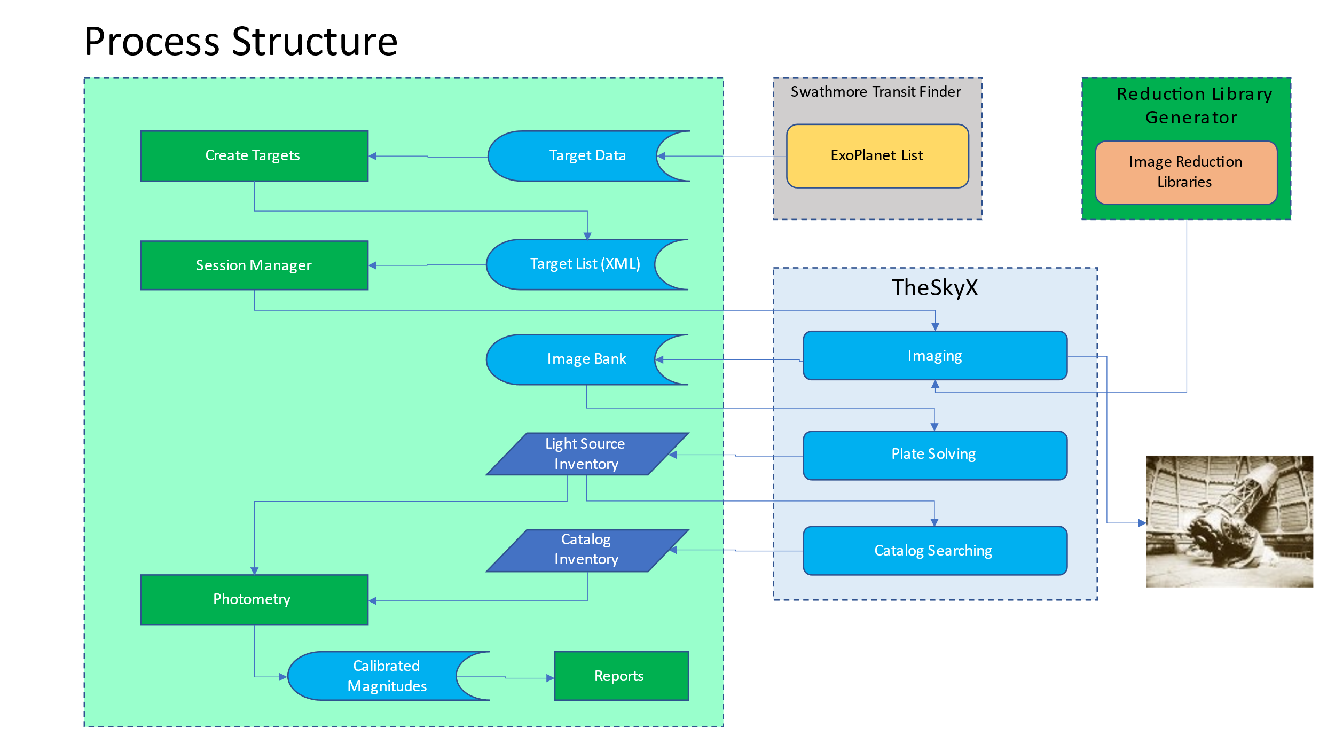

The diagram above blocks out the operational structure of the ExoScan app and its external dependencies. The exoplanet targets are generated through an on-line query to the Swarthmore object database. TheSky provides functionality for managing the mount and optical train, plate solving and catalog look-up. ExoScan itself is internally blocked into operations for importing target data, managing target image acquisition and processing photometry. The app maintains three database files: the active target list (Target List), an image library (Image Bank) and a list of processed photometry data for each target (Starchive).

As indicated by the diagram, ExoScan executes in three steps: Target List Generation, Target Acquisition, and Target Photometry, optionally preceded by imaging and configuring noise reduction libraries.

Target List Generation

**Target Acquisition Session**

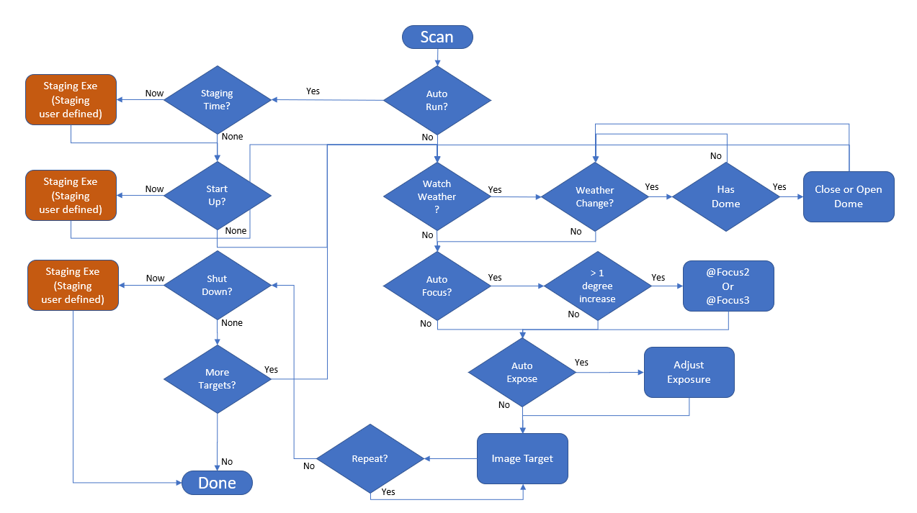

The Target Acquisition Session is managed through the opening Window’s form.

**Session Tab**

**Target Tab**

Targets, their respective images and derived data are organized into “Collections” so that the user can organize and manage separate target sets.

Current Target: Current list of targets for this collection.

Survey Swarthmore: The user can add an additional target to the collection by entering a new name in the Targets field. That target must be in an open catalog in TSX in order to acquire its celestial location (RA, Dec).

Target Selection: List of potential targets from Swarthmore Transient Search.

Add via Swarthmore: Load the target data from the Swarthmore survey.

Add via TSX: Look up the target data from TheSky. No transit information will be available.

Filter List: Along with the target list, the user must pick at least two filters to image during each session for each target.

**SettingsTab**

**Enables AutoRun. See the AutoRun tab.

Watch Weather: An AAG CloudWatcher output file is monitored for unsafe weather conditions.

Has Dome: ExoScan will use simple open and close dome commands in the event of untoward weather.

Images Per Sample: Sets the number of successive images that will be taken of each target in its turn. With multiple images the magnitude accuracy for a session can be improved with additional statistical analysis. However, the total number of targets that are imaged during a session will decrease accordingly.

Min Interval Between Samples: A target will only be imaged if this number of hours has expired since the last image. For instance, if the hours are set to 12, then a new image of each target will not be taken in the same night, even if ExoScan is run multiple times. Another use of this parameter is to help work through a large list over multiple nights. If the value is set to 36, then a second successive night’s session will begin where the last session left off. If it takes three nights to get through a list, then a user could set the value to 60, and so on.

*For exoplanet occultations, this value is set to less than the image sampling time. This causes ExoScan to continually take images over the time period of the occultation.*

Minimum Altitude: Restricts targets to above this limit. Important over long scans.

Camera Temperature: Sets the CCD temperature for the session.

Image Reduction Type: Choose the image reduction type: None, Auto or Full. Full is recommended. Full requires the creation of calibration libraries in TheSky, one calibration group for each filter to be used. Calibration library groups consist of sets of bias, dark and flat frames as explained in the TheSky User Guide. The only additional requirement for ExoScan is in a naming convention for the Reduction Group. The user must append an underscore and then the filter name (used for the flat frame set): ThisCalLibrary_R”. Any number of underscores can be placed in the group name, but the last must precede the filter name and, obviously, no underscores can be used in the filter name itself. The developer recommends using the TSXToolKit utility *Generate Reduction Library*.

PA 0 East: If the user has a rotator, then it’s position may not at 0 degrees PA East upon launch of ExoPlanet. The rotation angle is important for flats when using full calibration. If PA 0 East is checked, then ExoScan will run a short routine to ensure that the rotator is at 0 degrees PA East before starting.

Maximum Exposure: Sets the length of exposure in seconds for each image, or, if AutoExpose is selected, this value sets the maximum exposure time.

AutoExpose: If checked, ExoScan will attempt to determine an exposure that produces a maximum ADU value for the target star which is near the MaxADU setting, but no more than the Maximum Exposure. The optimization may take several subframe exposures to find the correct setting.

Max ADU: A value for the maximum ADU that the CCD response remains linear.

Enable CLS: If checked, a Closed Loop Slew (Precision Slew) will be performed rather than a simple slew to center the target for imaging. Several ExoScan subfunctions rely on the target placement very near the center of each image. However, CLS requires two successive image links and can take up to half a minute or so. If the user is confident that a simple slew is sufficiently accurate on its own, then the CLS can be turned off.

CLS Reduction: By default, a CLS uses whatever image reduction was applied to the most recently acquired image. Specifically choosing a CLS reduction method in this field will override that default.

AutoFocus -> Type: The camera will be focused at the start and whenever the temperature changes by one degree while the scan is underway. None, @Focus2 or @Focus3 can be selected.

AutoFocus -> Preset: After each focus during a session, ExoScan will average that focus temperature/position with all previous focuses during the session. The values of steps per degree and position at zero are stored at the end of each session. If Preset is selected, then these values are used to position the focuser at a starting position, depending upon temperature, at the start of the next session. This setting is not recommended if temperature changes are less than a few degrees over a session or between sessions as poor results may occur.

AutoFocus -> Focus Filter Index: Sets the filter to be used for either @Focus2 or @Focus3.

**AutoRun Tab**

AutoRun Configuration and Operation

The AutoRun form sets session event times and pointers to user scripts or programs that are to be executed at those times: Session Start (Staging), Imaging Start (Starting) and Session Termination (Ending). The Staging time allows a script or app to be run that, for instance, opens and cools down a dome. The Start time is when imaging is begun. An app run at that time can turn on and initialize the mount and imaging train. The Ending time sets a hard stop for the imaging session, for instance, dawn. The app run here would park and power down all systems.

If AutoRun has been previously selected, ExoScan will open with this window automatically in the expectation that the Autorun configuration times will need resetting for the new session.

**Command Buttons**

Stay On Top: The ExoScan application window will always show on top of all other windows.

Imaging: Starts the survey session. If AutoRun is set, then the session waits until the Staging time (if checked) and runs the Staging app (if configured), then waits until the Start time, runs the Start app and begins imaging the targets. When all qualified targets are imaged, or the End time occurs, the session is stopped and the Shut Down app (if any) is run.

Photometry: Starts the image photometry process. Cannot be run when Imaging is underway. See below.

Close: Ends the ExoScan session.

Abort: Terminates the scan and closes the session, as soon as feasible. This might take awhile.

**Photometry Operation**

Comparative photometry determines the apparent magnitude of the target object relative to the apparent magnitudes of a validated set of cataloged stars in an image. The app uses a TheSky Image Link to produce a instrument data for a set of light source prospects (Inventory Arrays), and produce a list of which sources (WCS Array) were selected as sufficiently star-like to use for plate solving. The qualification process merges the Inventory data lists onto the WCS Array and uses THESKY to look up a cataloged star to match each qualified star. Then, in combination with the cataloged data, the instrument data from the Inventory Array is translated into magnitude photometry for the target object. The result is stored for subsequent analysis and reporting, ostensibly to AAVSO.

Underlying plate solving in TheSky is a widely used Astrometry/Photometry engine called SExtractor. This tool combs an image for light sources and characterizes them in terms of instrument magnitude, shape and position on the image. The instrument magnitude data is consistent across the image, but overall dependent upon exposure and gain among other factors. Thus, the instrument magnitude can be treated as essentially unitless, and must be converted to calculate the apparent magnitude for the target star of the image. Conversion requires calibration of the cataloged apparent magnitudes of a set of stars to their correlated light sources in the image. This calibration is then used to convert the value of the target light source to an apparent magnitude. Furthermore, such a calibration allows the conversion to be largely independent of the usual corrections necessary for accurate photometry, seeing, air mass, exposure, etc. The light source instrument magnitude is directly correlated to cataloged magnitude rather than derived directly from the ADU’s.

ExoScan calibrates stars from two catalogs: APASS (DR9) and GAIA (DR2). From each of these catalogs, ExoScan uses TheSky to find the nearest cataloged star to each light source. A light source is considered qualified for calibration of the catalogs to the light sources if:

1) the light source ADU is within the linear range of the detector,

2) nearby cataloged stars are found in both catalogs, and

3) both register as located within twice the FWHM radial distance from the light source.

The registered apparent magnitudes of these qualified stars are linearly regressed to determine the calibration coefficients for each catalog. The population standard error for this linear regression sets the accuracy of the calibration, and so sets the accuracy of the conversion of the target light source to an apparent magnitude.

**Photometry Window**

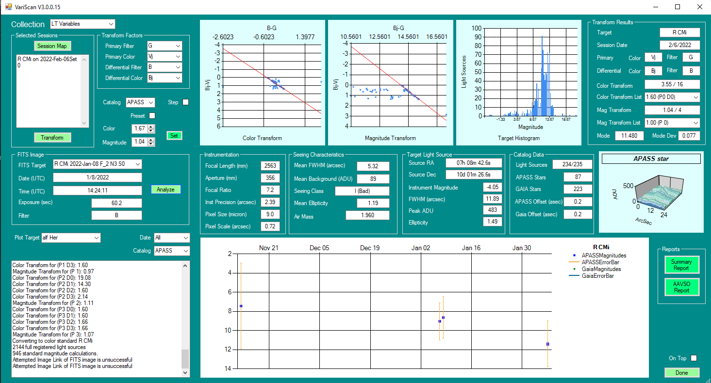

Photometry converts image sets to produce a standard magnitude for a target. Image sets are organized by target and session date. A session date spans the 12 hour period from 6PM to 6AM local time as referenced by the time at midnight. Normally a user would process all of the images from a session upon conclusion (Full Scan). However, the app allows transformation of individual targets for specific sessions as well (Target Session Group). During the transformation process, graphs for the color and magnitude transforms are displayed as well as a histogram of the individual standard magnitude results for the permutations of primary and differential images. Final results are displayed (Transform Results Group) and stored in the Starchive file. Rerunning analysis for an individual target (Transform) will overwrite past results, but Full Scan will not. To recompute results using Full Scan, the user selects “Clear Date” which removes all Starchive results for that session date.

The derived slopes for the color and magnitude transforms are not always accurate due to variations in the quality of the imaging and catalogs. While running a Full Scan, each derived transformation is saved and the mode (most common value) of each set are displayed in the preset Color and Magnitude fields. By selecting “Use Preset Transforms” these modal values can be used rather than computing new transforms for each target. Thus the user can run an evaluation for a session, clear the date, select the preset transforms, then rerun Full Scan on that session to produce potentially better results.

The FITs section of the window is for running diagnostics on individual fits files from the Image Bank. The FITS target field offers a selection of image files from the Collection and Target on the Session Date to pick from. Analyze runs an Image Link and computes various data about the image and star field.

The lowest section of the window contains the output log (running update), magnitude vs time graph for the target and a selection of report generators.

**Commands and Fields Detail**

Collection (List) Selection list of target collections. Pick one for analysis. The most recently imaged collection is default. The user must create at least one Collection.

Selected Session Group

Session Map This command opens a grid display of available images in the collection. The grid is organized by target and date. Each entry contains the filter and image count for that target on that date. The user selects, by highlighting, the targets and dates to be analyzed. Control A is handy to pick all targets for all dates. Columns (dates) and rows (targets) can also be group selected. The grid can also be sorted through the usual means.

Transform Compute the standard color magnitude (primary color) for the selected targets and dates. Store the result in the Starchive file.

Catalog: Choose either APASS or Gaia catalogs for standard magnitude data.

Step (Diagnostic) Pause after each transform calculation for monitoring.

Preset Select to enable the preset color and transform fields. While analyzing a full session, ExoScan will record a running average of the most common (mode) color and magnitude transforms. These values will be displayed in the Color and Magnitude fields (below). Upon completion of the session analysis, the user can choose to rerun the session analysis using these fields rather than computing transforms for each image combination. Alternatively, the user can enter these fields manually and generate results.

Color Color Transform value, either derived or manually entered

Magnitude Magnitude Transform value, either derived or manually entered

Set: Store the current Color and Magnitude fields as presets for the associated calalog..

Transform Factors Group

Primary Filter Selectable list of filters as imaged on the session date/target to use as the primary filter

Primary Color Selectable list of standard colors to which to compute from this date/target

Differential Filter Selectable list of filters as imaged on the session date/target to use as the differential filter

Differential Color Selectable list of standard colors to use as the differential color from which to compute the standard color (for this date/target)

Target Results Group (filled upon completion of each transformation)

Target Name of target star

Session Date Date of imaging

Primary Color/Filter Primary standard color to be computed and primary filter applied

Differential Color/Filter Differential standard color and filter applied

Color Transformation Color transformation selected and applied

Color Transformation List All color transformations computed primary and differential images

Magnitude Transformation Magnitude transformation selected and applied

Magnitude Transformation List All magnitude transformations computed from primary and differential images

Mode Histogram mode of all field to target transformations of standard color magnitude.

Mode Dev Standard deviation of standard color magnitude calculations for target within the histogram bucket of the mode.

Fits Image Group (Diagnostic)

Fits Target List List of images available for selected target on selected date

Date Image date from selected file fits data

Time Image time from selected file fits data

Exposure Image exposure from selected file fits data

Filter Image filter from selected file fits data

Instrumentation Group (fields populated from TheSky data)

Focal Length Focal length of imager

Aperture Aperture of imager

Focal Ratio Focal Ratio of imager

Instrument Precision Instrument resolution in arcsec

Pixel Size Size of pixels of imager in microns

Pixel Scale Arcsec per pixel of imager

Seeing Characteristics Group

Mean FWHM Average FWHM for star field

Mean Background Average background noise for image

Seeing Class Computed seeing class of image

Mean Ellipticity Average ellipticity of light sources in image

Air Mass Atmospheric air mass at location, direction and time of exposure

Target Light Source Group

Source RA RA location of light source on image determined to be the target

Source Dec Dec location of light source on image determined to be the target

Instrument Magnitude SExtractor-computed instrument magnitude for this light source

FWHM SExtractor-computed FWHM for this light source

Peak ADU Peak image ADU for this light source

Ellipticity SExtractor-computed ellipticity for this light source

Catalog Data Group

Light Sources Number of cataloged light sources found. This is an active field used to show progress in the form of a running total and total to be cataloged.

APASS Stars Number of light sources with APASS catalog data

Gaia Stars Number light sources with Gaia catalog data

APASS Offset Scalar distance from claimed location of target and closest light source in APASS catalog

Gaia Offset Scalar distance from claimed location of target and closest light source in Gaia catalog

Graphs

Color Transformation Plots the filter/color differentials for the color transformation.

Magnitude Transformation Plots the filter/color differentials for the magnitude transformation.

Target Histogram Plots the number of standard magnitudes for the target star as calculated from each field star/target star combination in the images. Resolution is 100 buckets over the range of calculated standard magnitudes.

Star Instrument Magnitude Diagnostic representation of the ADU field for the target star in the selected FITS image.

Reports

Summary A comprehensive report of most of the displayed data in CSV format such that multiple images taken during the same night are statistically combined

AAVSO A CSV file using all target data condensed and list in the format defined by the AAVSO Extended Submission guidelines.

**Change Log;**

**Rev 1.0:** Initial release

Rev 1.1: Added CLS management functions

Rev 3.0: Bunch of stuff associated with exoplanet surveys

**Appendix 1: File Structure**

**Appendix 2: Set-Up**

**Adding the APASS Star Catalog**

TBD

**TheSky ProDatabase Manager Set-Up**

ExoScan uses four star catalogs: APASS, Gaia, GCVS and Hipparcos-Tycho (for CLS and Image Linking). These databases must be enabled in the TheSky Pro Database Manager. Enabling additional databases merely slows processing down.

**Image Calibration Library Set Up**

ExoScan requires that Noise Reduction (Calibra tion) folders have the format:

B<b>_T<t>_E<e>_F<f>

where

*<b>* = binning: “1x1”, “2x2”, etc

*<t>* = temperature in Centigrade: “-x.x”

*<e>* = exposure in seconds: “e.ee”

*<f>* = filter name: “C”, “R”, “B”, “V”, etc

Examples

“B1x1_T-20.2_E35.00_FC”

“B2x2_T-10.0_E180.00_FR”

This format enables ExoScan to select the correct image reduction folder based on each image exposure.

The easiest way to prepare for a full reduction library, is to use the TSXToolKit utility *Reduction Library Generator* which can be downloaded from GitHub/rrskybox/Reduction Library Generator in same manner as ExoScan itself. This utility will parse a directory and subdirectories for reduction files, compile their paths into the folder structure and naming conventions, then directly modify the TheSky configuration file to accept the libraries. TheSky must be restarted once to load the library structure.

**Appendix 3: Differential Color Transformations**

**

Differential Photometry Definitions:

A “Standard” color is the published magnitude value in one or more colors (B,V,R,U,I) for an object, usually written capitalized, or the equivalent transformation to these “standard” colors of the published Gaia magnitude values (G, Gbp, Grp).

A “Instrumental” value is an instrument magnitude value in some filter passband (b, u, v, r, I, r, g, b, clear, etc) for an object, usually written lower-case. Instrument magnitude is that produced by SExtractor for a light source.

“Primary” refers to a calculated magnitude for an object in a Standard color and the Instrumental filter chosen to transform to that standard color.

“Differential” refers to the standard magnitude and the instrument filter chosen to be used as a differential to the Primary in determining the transformations from the instrument magnitudes.

“exo” refers to a magnitude (catalog or instrument) of the target star.

“fld” refers to a magnitude (catalog or instrument) of a field star.

“Pexo” is the computed magnitude for the target star for this image in the chosen primary standard color band.

“Pfld” is the cataloged standard magnitude for a field star.

“pexo” is the instrument magnitude of the target star for this image using the primary filter.

“pfld” is the instrument magnitude for a field star for this image using the differential filter.

Formula:

T(d-p/d-P) =>Color Transform is the inverse of the regressed slope of mean (d-p)/(d-P) over images.

T(D-p/D-P) => Magnitude Transform is the regressed slope of mean (D-p)/(D-P) over images.

Generic Equation (see notes below on terms):

Δp = pexo – pfld

Δ(d-p) = T(D-p/D-P) * [(dexo-pexo)-(dfld-pfld)]

Δ(D-P) = T(D-p/D-P) * Δ(d-p)

Pexo = Δp + T(d-p/d-P) * Δ(D-P) + Pfld

Example for computing target magnitude in Gg color from Ag (primary) and Ar (differential) filters and cataloged Gg (Primary) and Gr (Differential) magnitudes:

Δp = Agexo – Agfld

Δ(d-p) = T(Ar-Ag/Gr-Gg) * [(Arexo-Agexo)-(Arfld-Agfld)]

Δ(D-P) = T(Gr-Ar/Gr-Gg) * Δ(d-p)

Pexo = Δp + T(Ar-Ag/Ar-Gg) * Δ(D-P) + Ggfld

Methodology:

To obtain Vvar (calculated magnitude in V color of target object) for a Session Sample

1. Image Link N primary (g) filter images and M differential (b or r) filter images (normally N=M)
2. Create a primary magnitude array of target light source locations and instrument magnitudes for each primary image.
3. Create a differential magnitude array of target light source locations and instrument magnitudes for each differential filter image.
4. Select a master magnitude array from the primary magnitude arrays.
5. Determine nearby cataloged APASS, Gaia and GCVS stars to each master magnitude array light source location.
6. Register other primary magnitude array light sources and all differential magnitude array light sources against master magnitude array using closest points algorithm.

Calculate color transform, Tvb. Regress cross-product over NxM magnitude arrays of v and b (or r) filters.

Formula: 1 / Regression Slope[(b-v)/(B-V)]

Calculate magnitude transform, Tv_bv. Regress over N images of v magnitude arrays.

Formula: Regression Slope[(B-v)/(B-V)]

For the target star in each primary image,

For each comparison star,

Calculate Δ(b-v) => (b-v)var- (b-v)ref

Calculate Δ(B-V) = Tbv * Δ(b-v)

Calculate Δv = vvar – vcomp

Vvar = Δv + Tv_bv * Δ(B-V) + Vcomp

Compute mean Vvar for all comparison stars

Compute mean Vvar for all images

Process Flow:

1. Set up configuration for primary and differential standards (P, D) and primary and differential filters (p,d) during target sessions – e.g. shoot set of images in two or more filters.
2. A “sample” is a set of images from 2 or more filters shot within a single night, presumably within minutes of each other.
3. Read light sources from images from sample
4. Image Link each differential filter image -> light source array
5. Image Link each primary filter image -> light sources array
6. Select light source array for registration master.
7. Register light source arrays against registration master (by index)
8. Populate master light source array with catalog data for stars close to each light source.
9. Pick a registered light source as the target.
10. Calculate Color Transformation and Magnitude Transformation w/ error
11. Transform target instrument magnitude to standard magnitude for each primary image
12. Average all transformed standard target magnitudes for result

**Appendix 5: AAVSO Extended File Format (https://www.aavso.org/aavso-extended-file-format)**

**Version: 1.2**

**Release Date: July 27, 2011 (latest update: June 13, 2017)**

This is one of two plain text (ASCII) formats that the AAVSO accepts for uploading a file of variable star observations. Please use the WebObs File Upload page to upload your file in the AAVSO Extended Format. The other format, which is intended for visual observers, is called the AAVSO Visual File Format.

Visit the Software that exports to AAVSO format page to help format your observations.

The extended format has two components: parameters and data. Each component is discussed in detail below.

The format is not case sensitive. The only acceptable file extensions are .txt, .csv, and .tsv.

Parameters

The Parameters are specified at the top of the file and are used to describe the data that follows. Parameters must begin with a pound sign (#) at the start of the line. There are six specific parameters that we require to exist at the top of the file. Personal comments may also be added as long as they follow a pound sign (#). These comments will be ignored by the software and not loaded into the database. However, they will be retained when the complete file is stored in the AAVSO permanent archives.

The six parameters that we require are:

#TYPE=Extended

#OBSCODE=

#SOFTWARE=

#DELIM=

#DATE=

#OBSTYPE=

The six parameters explained:

* TYPE: Should always say Extended for this format.
* OBSCODE: The official AAVSO Observer Code for the observer which was previously assigned by the AAVSO.
* SOFTWARE: Name and version of software used to create the format. If it is private software, put some type of description here. For example: "#SOFTWARE=AIP4Win Version 2.2". Limit: 255 characters.
* DELIM: The delimiter used to separate fields in the report. Any ASCII character or UNICODE number that corresponds to ascii code 32-126 is acceptable as long as it is not used in any field. Suggested delimiters are: comma (,) semi-colon(;), exclamation point(!), and pipe(|). The only character that cannot be used is the pound (#) and the " " (space). If you want to use a tab, use the word "tab" instead of an actual tab character. Note: Excel users who want to use a comma will have to type "comma" here instead of a ",". Otherwise Excel will export the field incorrectly.
* DATE: The format of the date used in the report. Times are midpoint of the observation. Convert all times from UT to one of the following formats:
* JD: Julian Day (Ex: 2454101.7563)
* HJD: Heliocentric Julian Day
* EXCEL: the format created by Excel's NOW() function (Ex: 12/31/2007 12:59:59 a.m )
* OBSTYPE: The type of observation in the data file. It can be CCD, DSLR, PEP (for Photoelectric Photometry), or VISDIG (for VISual observations made from DIGital images). If absent, it is assumed to be CCD. [If you are submitting photographic/photovisual observations, please use the Visual File Format instead of the Extended File Format. See the Visual File Format explanation for details.]

The OBSCODE and DATE parameters may also be included elsewhere in the data. Our data processing software will read these parameters and will expect all following data to adhere to them. (For example, you can add "#OBSCODE=TST01" to the report and all subsequent observations will be attributed to observer TST01.)

If you want to put a blank line between your parameter records and your data records, be sure to comment the line out with the pound sign (#). WebObs will not accept a file with blank lines that are not commented out.

Data

After the parameters comes the actual variable star observations. There should be one observation per line and the fields should be separated by the same character that is defined in the DELIM parameter field. If you do not have data for one of the optional fields, you must put "na" as a place holder. The list of fields are:

* STARID: The star's identifier. It can be the AAVSO Designation, the AAVSO Name, or the AAVSO Unique Identifier, but NOT more than one of these. Limit: 30 characters.
* DATE: The date of the observation, in the format specified in the DATE parameter. Limit: 16 characters.
* MAGNITUDE: The magnitude of the observation. Prepend with < if a fainter-than. A dot is required (e.g. "9.0" rather than "9"). Limit: 8 characters.
* MAGERR: Photometric uncertainty associated with the variable star magnitude. If not available put "na". Limit: 6 characters.
* FILTER: The filter used for the observation. This can be one of the following letters (in bold):
  + U: Johnson U
  + B: Johnson B
  + V: Johnson V
  + R: Cousins R
  + I: Cousins I
  + J: NIR 1.2 micron
  + H: NIR 1.6 micron
  + K: NIR 2.2 micron
  + TG: Green Filter (or Tri-color green). This is commonly the "green-channel" in a DSLR or color CCD camera. These observations use V-band comp star magnitudes.
  + TB: Blue Filter (or Tri-color blue). This is commonly the "blue-channel" in a DSLR or color CCD camera. These observations use B-band comp star magnitudes.
  + TR: Red Filter (or Tri-color red). This is commonly the "red-channel" in a DSLR or color CCD camera. These observations use R-band comp star magnitudes.
  + CV: Clear (unfiltered) using V-band comp star magnitudes (this is more common than CR)
  + CR: Clear (unfiltered) using R-band comp star magnitudes
  + CBB: Clear with blue-blocking (used for exoplanet observations).
  + SZ: Sloan z
  + SU: Sloan u
  + SG: Sloan g
  + SR: Sloan r
  + SI: Sloan i
  + STU: Stromgren u
  + STV: Stromgren v
  + STB: Stromgren b
  + STY: Stromgren y
  + STHBW: Stromgren Hbw
  + STHBN: Stromgren Hbn
  + MA: Optec Wing A
  + MB: Optec Wing B
  + MI: Optec Wing C
  + ZS: PanSTARRS z-short (APASS)
  + Y: PanSTARRS y (APASS)
  + HA: H-alpha
  + HAC: H-alpha continuum
  + O: Other filter not listed above, must describe in Comments. Please Note: Due to a problem in WebObs, this filter choice is currently unavailable. Please consider removing your filter and using CV or TB/TV/TR instead.
* TRANS: YES if transformed using the Landolt Standards or those fields that contain secondary standards, or NO if not. Document the method used to transform in the "NOTES" section.
* MTYPE: Magnitude type. STD if standardized (Click here for definition of standardized) or DIF if differential (very rare). If you are currently using ABS for 'absolute' we will still accept it. Differential requires the use of CNAME.
* CNAME: Comparison star name or label such as the AUID (much preferred) or the chart label for the comparison star used. If not present, use "na". Limit: 20 characters.
* CMAG: Instrumental magnitude of the comparison star. If "ensemble" see example below. If not present, use "na". Limit: 8 characters.
* KNAME: Check star name or label such as the AUID (much preferred) or the chart label for the check star. If not present, use "na". Limit: 20 characters.
* KMAG: Instrumental magnitude of the check star. If "ensemble" see example below. If not present, use "na".Limit: 8 characters.
* AIRMASS: Airmass of observation Limit 7 characters - entry will be truncated if longer than that. If not present, use "na".
* GROUP: Grouping identifier (maximum 5 characters). It is used for grouping multiple observations together, usually an observation set that was taken through multiple filters. It makes it easier to retrieve all magnitudes from a given set in the database, say, if someone wanted to form color indices such as (B-V) with them. If you are just doing time series, or using the same filter for multiple stars, etc., just set GROUP to "na." For cases where you want to group observations, GROUP should be an integer, identical for all observations in a group, and unique for a given observer for a given star on a given Julian Date. Limit: 5 characters.
* CHART: Please use the sequence ID you will find written in Bold print near the top of the photometry table in a sentence that reads "Report this sequence as [ID] in the chart field of your observation report." If you used your own comparison stars (e.g. in the case of time-sensitive alerts when the Sequence Team had no time to create a sequence), do not give a chart ID, even if you plotted the chart using VSP. Use the comment code K (non-AAVSO chart) and give a proper chart name like "APASS DR10". Then add information on the comp stars in the notes. Limit: 20 characters.
* NOTES: Comments or notes about the observation. If no comments, use "na". This field has a maximum length of several thousand characters, so you can be as descriptive as necessary. If you used your own comparison star sequence, identify your comp stars. E.g.: "Comp stars 123 = GSC 01234-56789 (12.25V) and 127 = GSC 01234-67890 (12.71V)." One convention for including a lot of information as concisely as possible is to use subfields in the format |A=B; the '|' character is the separator, A is a keyvalue name and B is its value. If you need an alternative delimiter from '|', use it but preceed the first instance with "DELIM=". Using this mechanism you can document your transform process in more detail.

Appendix 5: Generation of a Standard Star Calibration List

1. AAVSO Standard Star Catalog

Creating and loading AAVSO AUID catalog

1. Creating and Running Standard Star Observing List

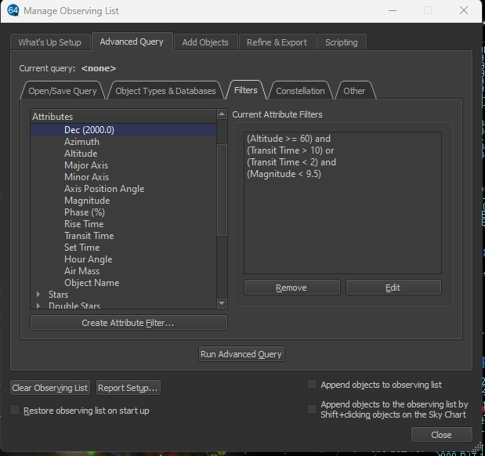

Columns must be ordered as shown.

